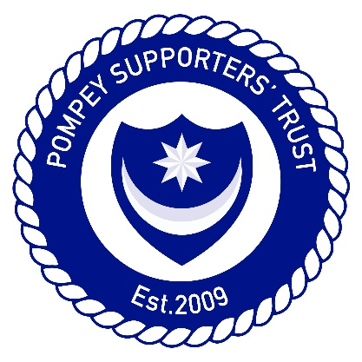

KEN MALLEY ‘FAN OF THE YEAR’ AWARD
SPONSORED BY THE POMPEY SUPPORTERS’ TRUST

An annual award that celebrates the achievements of Pompey supporters in honour of former PST Chairman Ken Malley who firmly believed that Pompey fans were unrivalled in their passion and commitment.

These days there are a glut of end of season awards for Player of the Season and it is an acknowledged crowded market, but the alternative idea of the creation of an annual Fan award in memory of Ken Malley was floated amongst the PST Board and accepted as a worthy memorial.
Nominations will be made by Pompey fans of an individual or group who they deem worthy of receiving the award for the season.
It will be up to those persons nominating to make the case of why they think the individual should win and then a shortlist will be put together by an expert panel. The panel will be led by Pam Wilkins and assisted by Johnny Moore, Barry Dewing and Del Pulley.
It could be for services to Charity which is achieved through following Pompey or for some other act of kindness or generosity, or maybe that person has not missed a game for 20 years and deserves recognition?
PST Members will get to vote on who they think should win from the shortlist provided and a presentation will be made before the end of the 2015-2016 season.

Please see the form below to complete. Forms can be emailed to trustmatters@pompeytrust.com handed into the Pompey Bus on a Saturday matchday or sent to our postal address:
PST, c/o Pompey Study Centre,
Anson Road,
Portsmouth,
PO4 8TB

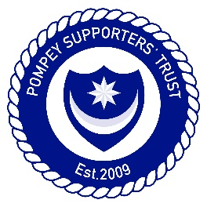

PST KEN MALLEY ‘FAN OF THE YEAR’ NOMINATION FORM

Name of Fan/group being Nominated:
Contact Details: (Address/Email/Phone):

Name of Nominator/s:
Email Address:
Phone Number:

Reason for Nomination:

